WORD | DEFINITION/EXAMPLES | Memory Clue
SAHARA | Ex: Sahara Desert
SAHEL | Ex: the African sahel | 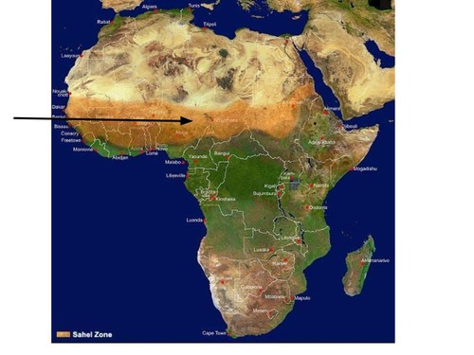
SAVANNA | -An area of grassland with scattered trees and bushes  Ex:
TROPICAL RAIN FOREST | Ex: West African tropical rain forests
DROUGHT |  | 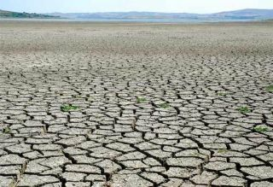
DEFORESTATION | permanent removal of trees to make room for something besides forest. This can include clearing the land for agriculture or grazing, or using the timber for fuel, construction or manufacturing
DESERTIFICATION |  | 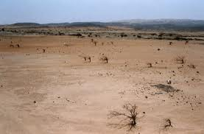
WATER POLLUTION | contamination of water bodies, usually as a result of human activities.
WATER SCARCITY
RIFT VALLEY
CANOPY | an ornamental cloth covering hung or held up over something, especially a throne or bed.
OASIS |  | 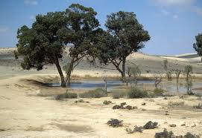
GORGE | a narrow valley between hills or mountains, typically with steep rocky walls and a stream running through it
SILT
CONFLICT DIAMONDS |  | 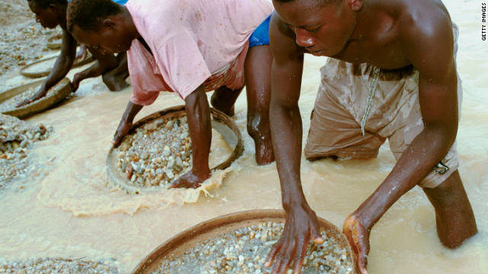
SUCCULENT*
ECOTOURISM*

