Name: __________________________________ Date: __________________ Period: ________

Africa’s Geography
SS7G1 – The student will located selected features of Africa.
- Locate on a world and regional political-physical map: the Sahara, Sahel, savanna, tropical rainforest, Congo River, Niger River, Nile River, Lake Tanganyika, Lake Victoria, Atlas Mountains, and Kalahari Desert
- Locate on a world and regional political-physical map: the countries of Democratic Republic of the Congo (Zaire), Egypt, Kenya, Nigeria, South Africa, Sudan and South Sudan.
SS7G2 – The student will discuss the environmental issues across the continent of Africa.
- Explain how water pollution and the unequal distribution of water impacts irrigation, trade, industry, and drinking water.
- Explain the relationship between poor soil and deforestation in Sub-Saharan Africa.
- Explain the impact of desertification on the environment of Africa from the Sahel to the rainforest.
SS7G3 – The student will explain the impact of location, climate, and physical characteristics on population distribution in Africa.
- Explain how the characteristics of the Sahara, Sahel, savanna, and tropical rainforest affect where people live, the type of work they do, and transportation.

1. What is the largest desert in the world?
2. Describe the relative location of the African Sahel.
3. Into what body of water does the Congo River flow?
4. Into what body of water does the Niger River flow?
5. Into what body of water does the Nile River flow?
4. What is the longest river in Africa?
5. Describe Egypt’s relative location.
6. Describe Kenya’s relative location.
7. Describe Nigeria’s relative location.
8. Where do most of Egypt’s people live?
9. What is major problems facing those who depend on the Nile River for their water?
10. How did the Aswan High Dam change Egyptian farming?
11. What is silt?
12. In what region of Africa does the Niger river flow through?
13. What do some people believe might lead to “water wars” in Africa in the future?
14. What destroyed the grassland and forests that were once found in the Sahel?
15. Why are droughts a problem for farmers in the Sahel?
16. How has desertification affected the people living in the Sahel region?
17. What has been a major cause of desertification in Africa’s Sahel region?
18. Why has caused rainforest destruction?
19. Describe the Sahara region.
20. What is a nomad?
21. What is the name for a desert area that gets some rainfall?
22. Describe the Sahel region.
23. Which is a consequence of cutting down trees for fuel in the Sahel?
24. Describe the savanna region.
25. In what region of Africa would you likely find the most diversity of animals?
26. Describe the rainforest region.
27. What is the definition of “deforestation”?
28. What is responsible for the creation of the Great Rift Valley?

29. Know your vocabulary:
Sahel, Waterpollution,  Water scarcity  Rift Valley | Drought,  Rain Forest,  Canopy, | Desertification,  Oasis,  Succulent, | Deforestation,  Ecotourism,  Savanna, | Gorge,  Silt,  Conflict Diamond,

30. Be able to label both the physical and political maps of Africa.

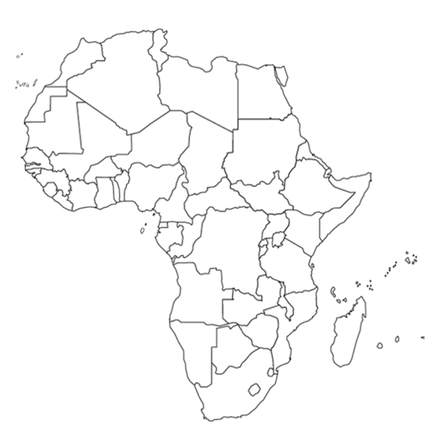

- Democratic Republic of the Congo (Zaire)
- Egypt
- Kenya
- Nigeria
- South Africa
- Sudan
- South Sudan

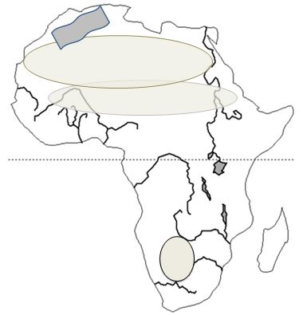

- Sahara
- Sahel
- Congo River
- Niger River
- Nile River
- Great Rift Valley
- Atlas Mountains
- Mount Kilimanjaro
- Lake Victoria
- Kalahari Desert
- Tropical Rain forest
- Savannah

