India History Questions
Pgs. 383-388

- What is nationalism?

- What is civil disobedience? Give two examples.

- How did World War II help India gain independence?

- Why and how was India partitioned?

- Who was Mohandas Gandhi? How did he impact India’s independence movement? Give three specific examples.

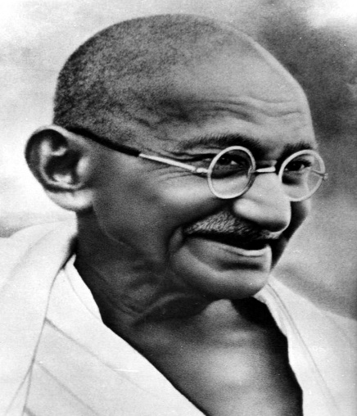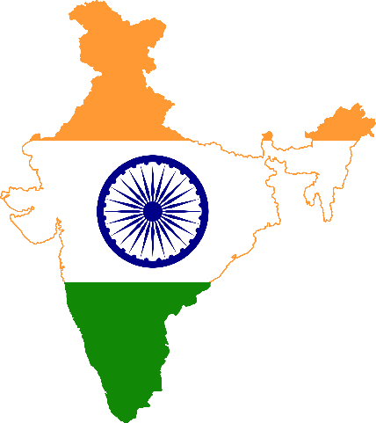

This Photo by Unknown Author is licensed under CC BY-SA

