India History Questions
Pgs. 383-388

- What is nationalism?

Nationalism is the belief that

- What is civil disobedience? Give two examples.

Civil disobedience is when people defy the government without using violence. Examples are

- How did World War II help India gain independence?

WW2 helped India gain independence because

- Why and how was India partitioned?

India was split into different countries because

- Who was Mohandas Gandhi? How did he impact India’s independence movement? Give three specific examples.

Gandhi was an important person to India because

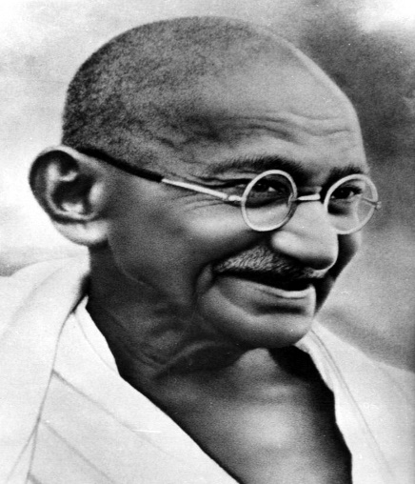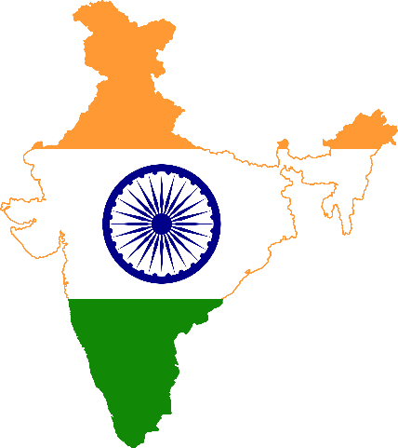

This Photo by Unknown Author is licensed under CC BY-SA

